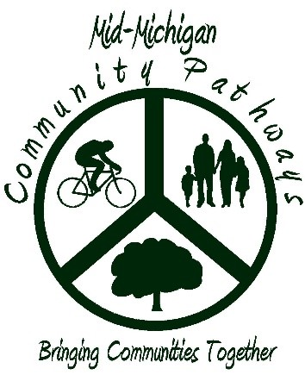

Mid-Michigan Community Pathways
Event Application Information

An event application is required for any organized activities utilizing Mid-Michigan Community Pathways, including but not limited to:
- Running and cycling competitions
- Fun runs
- Commercial use of the trail
- Ongoing recreation classes or programs utilizing the trail
- Any event that advertises use of the trail
- Any event where participation is controlled by fees or donation

Application Information:
- Arrangements for activities should not be finalized until approval is received from the Friends of Mid-Michigan Community Pathways.
- Applications must be received a minimum of 45 days prior to the activity date.
- Insurance requirements must be met and a proof of insurance needs to be received by the Friends Group a minimum of 10 days prior to your event, or your event will be cancelled.
- The trail shall remain open to the public during your event; please be courteous of other users.
- Security and traffic control at road crossings are the responsibility of the permit holder.

Application Fees:
The application fee can be made by cash or check payable to the Friends of Mid-Michigan Community Pathways and must be submitted with the application.

The fee structure is as follows:
For-Profit and unofficial non-profit organizations/informal fundraising groups $50.00
Non-Profit Organizations with proof of 501(c)3 status $25.00 Municipality or affiliated government and park agencies $ 0.00

Application Process:
- Contact Steve Davidson to check availability for your event at dpwsteve@yahoo.com or (989) 854-0147.
- Mail the completed application with payment to Friends of Mid-Michigan Community Pathways, C/O Steve Davidson, DPW, 208 W Boulevard St, Shepherd, MI 48883. The application and payment must be received a minimum of 45 days before the event date.

Event Rules
Permission to use any part of the Mid-Michigan Community Pathways trail for an event will only be given if these rules are followed. Permission and evaluation of the event will be performed by the Friends Group that has authority over the trail section being used.
Rules.
- Application to hold an event must be made 45 days prior to the date of the event.
- The permit holder is responsible for contacting municipalities and public safety to seek any permits needed.
- Only flour, sidewalk chalk or removable signage is allowed. NO PAINT OR CHALK PAINT. Do not attach anything to trees, benches, or signs.
- Permit holder is responsible for clean up. Make sure all garbage and signage is removed once the event is complete.
- This permit DOES NOT give exclusive use of the trails. Please be considerate of other community members on the trail.
- Any damage to the trail, trees, grounds, or infrastructure of the trail will be the responsibility of the permit holder.
- Insurance coverage is required in accordance with MDNR Insurance Requirements for the users of State Land. A copy of the insurance policy endorsement/rider must state the appropriate friends group (IE: Isabella County Friends of Mid-Michigan Community Pathways), MidMichigan Community Pathways, and the “State of Michigan, its departments, boards, agencies, commissions, officers, and employees are included as additional insured.”
- The Friends Group may refuse any event based on type of use, condition of the trail and/or conflict with other events.

Mid-Michigan Community Pathways and associated Friends Groups do not and shall not discriminate on the basis of race, color, religion, gender, gender expression, age, national origin, political affiliation, disability, marital status or sexual orientation in any of its activities or operations, to include the issuance or denial of trail event permits.

Mid-Michigan Community Pathways
Event Application

Name of Applicant/Organization: ________________________________________________
Contact Name: _________________________________________________________________
Address: ______________________________________________________________________
City/State/Zip: _________________________________________________________________
Phone: ______________________________ Email: _________________________________

Type of Organization:
___ For Profit, unofficial non-profit or informal fundraising group ($50.00 application fee)
___ Non-Profit with 501(c)3 status ($25.00 application fee)
___ Municipality or affiliated government and park agencies (No fee charged)

Name of Event: ________________________________________________________________
Type of Event: _________________________________________________________________
Date of Event: ___________________________ Start/End Time: _________________________
Onsite Contact (Day of event): ____________________________________________________ Expected Number of Participants: ____________ Specific Route Detail/Locations:
______________________________________________________________________________
______________________________________________________________________________
______________________________________________________________________________
I have read the Event Rules and agree to the terms and conditions stated therein.

Event Coordinator Signature: ______________________________ Date: __________________

Permission granted by Mid-Michigan Community Pathways and the Friends of Mid-Michigan Community Pathways:
___________________________________ ____________________________________
Mid-Michigan Community Pathways Friends of Mid-Michigan Community Pathways

